Finding few flags on CTF Rickdiculously Easy

Download here: <https://www.vulnhub.com/entry/rickdiculouslyeasy-1,207/>

Searching for the IP of the VM Rickdiculously Easy by using nmap scan

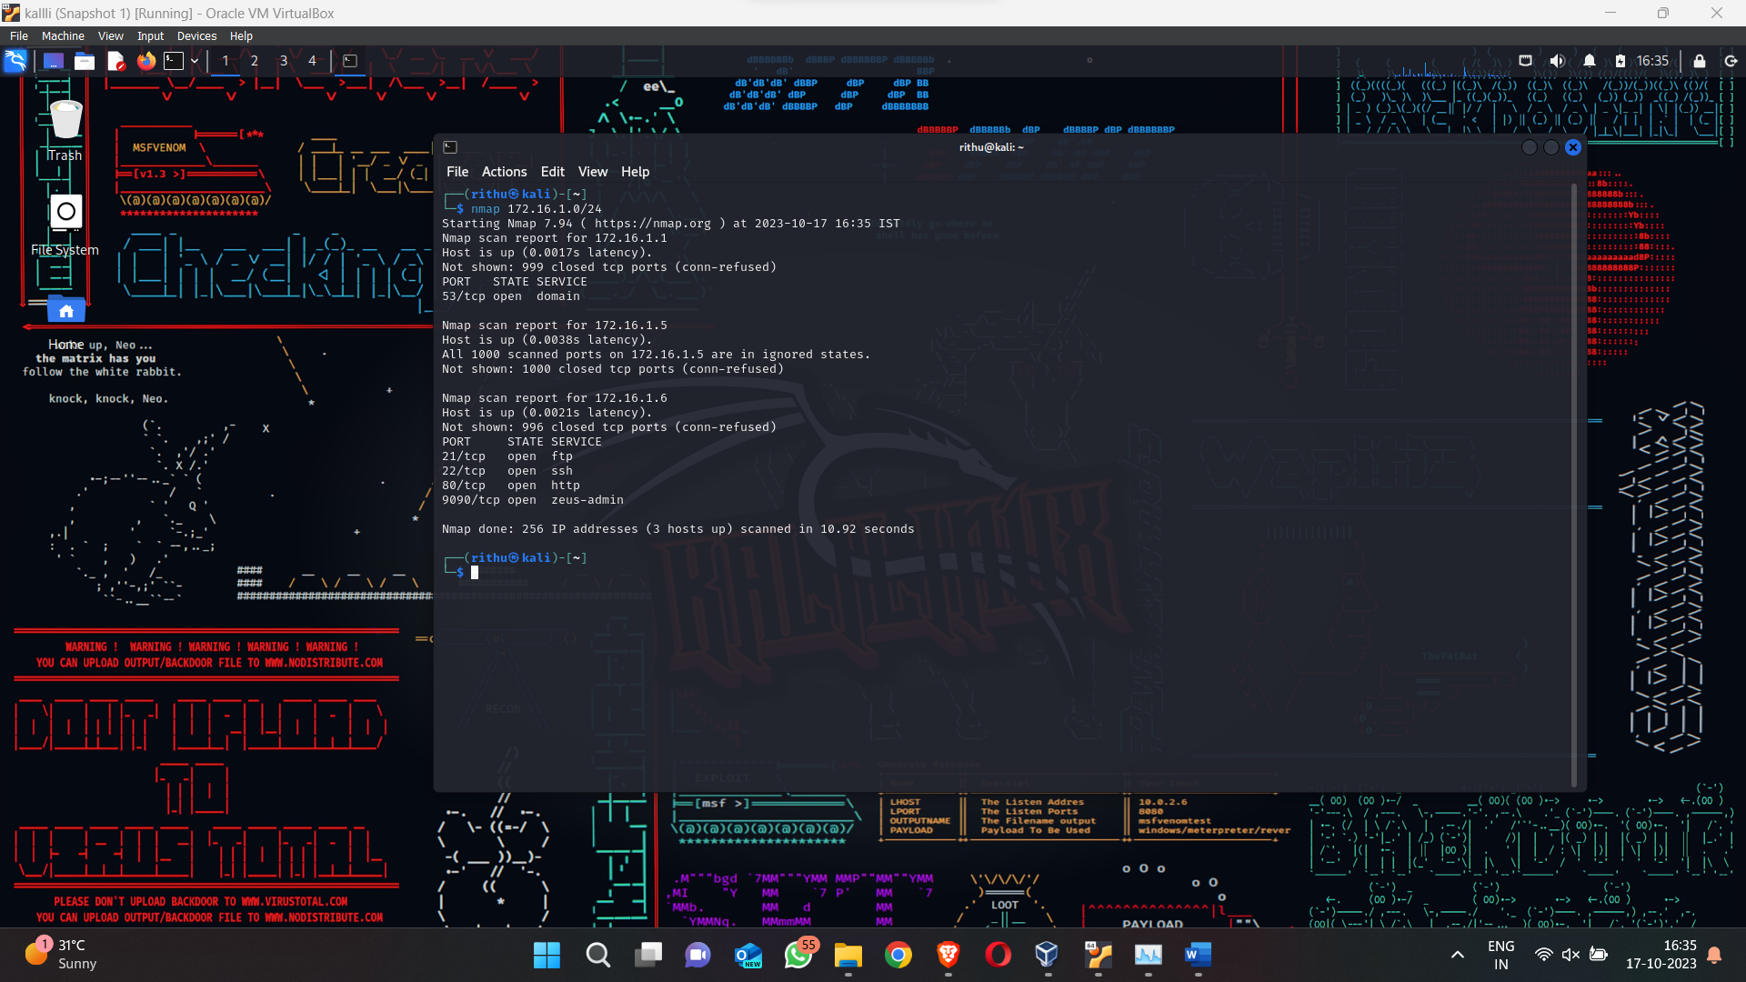

Getting the IP of VM as 172.16.1.6 entering it into the browser we get this not so informative website

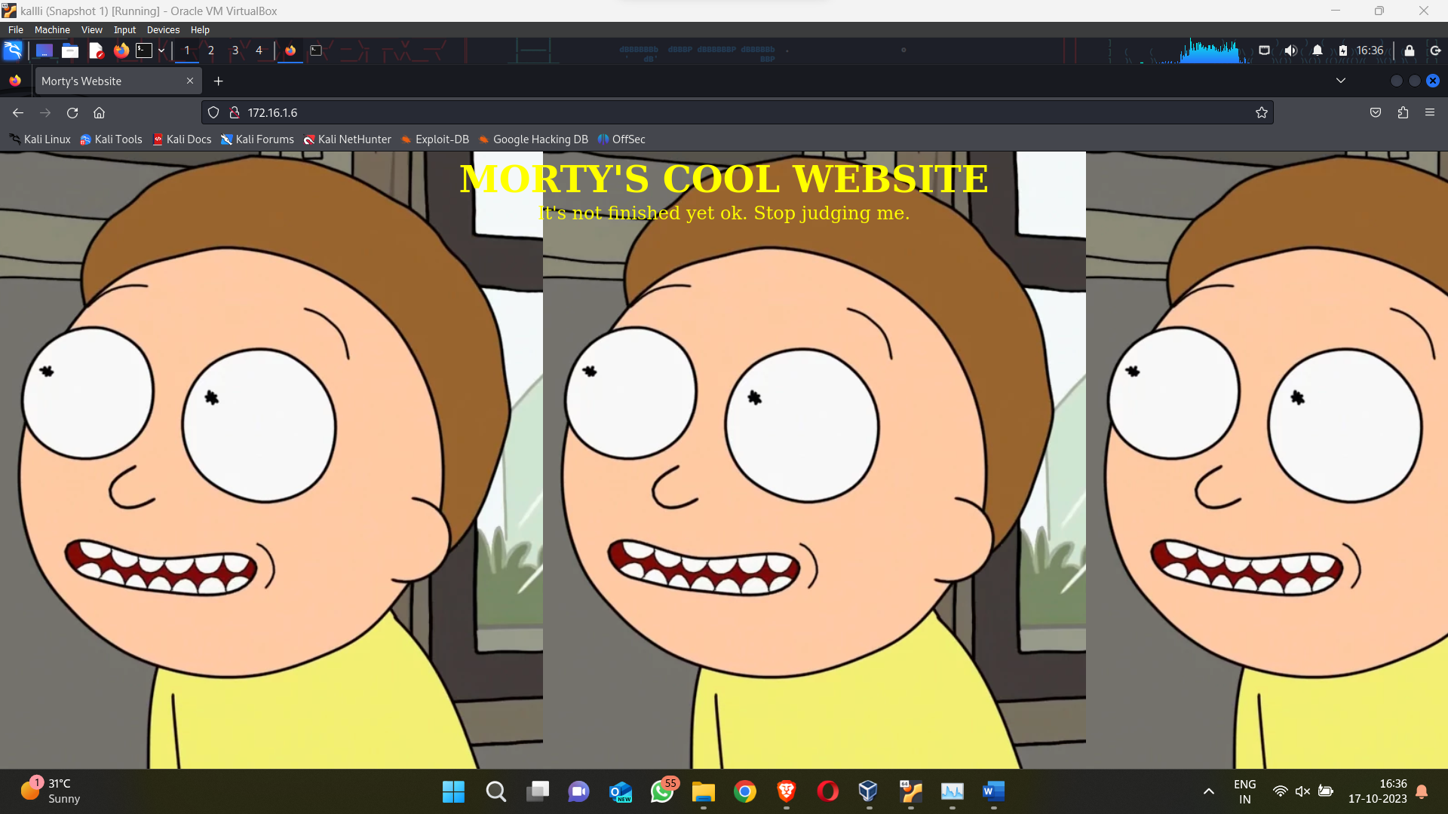

Checking the ports in which this IP operates using nmap scan

Here we get some interesting results as in port no. 9090, 13337, 60000 we have some unusual things going on

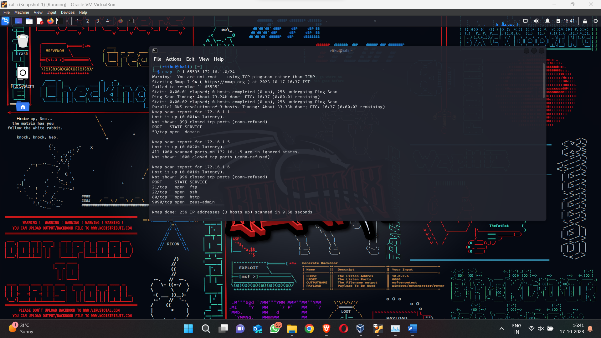

Going to browser and entering the IP address with the port no. we get out first flag 😊

FLAG 1

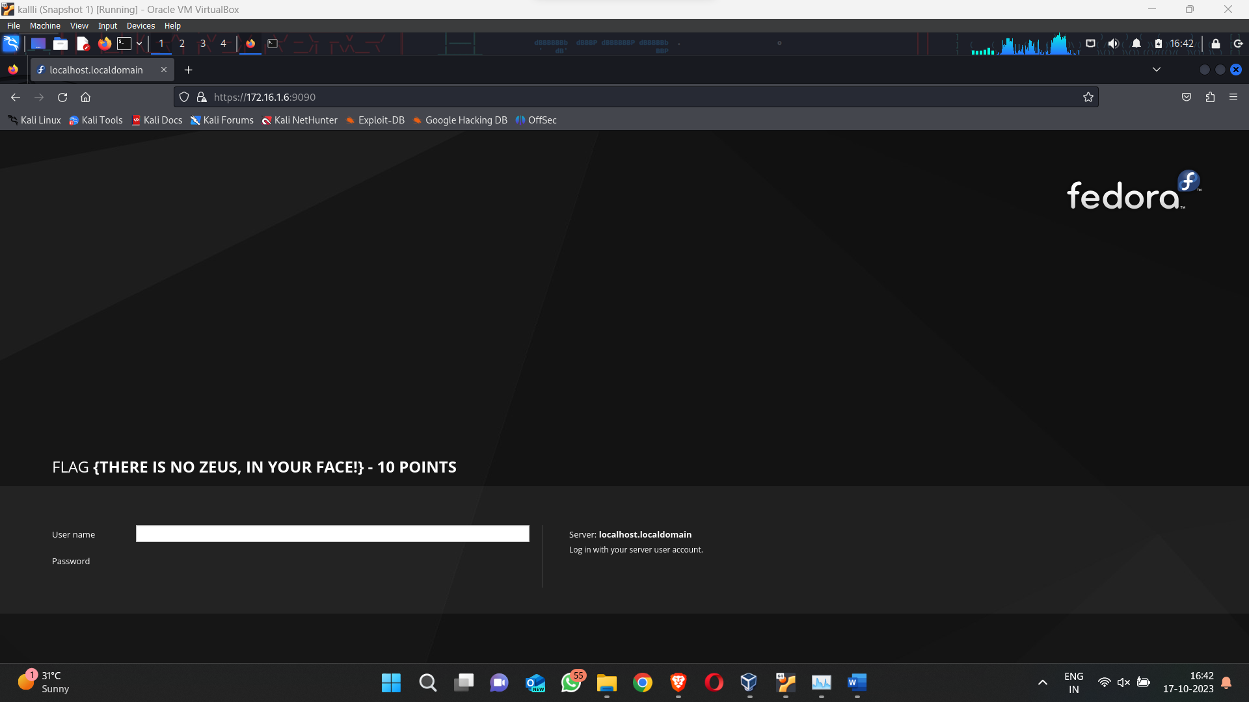

NC or netcat is used to read text between interfaces using netcat for port 13337 and 60000 we get 2 flags

FLAG 2

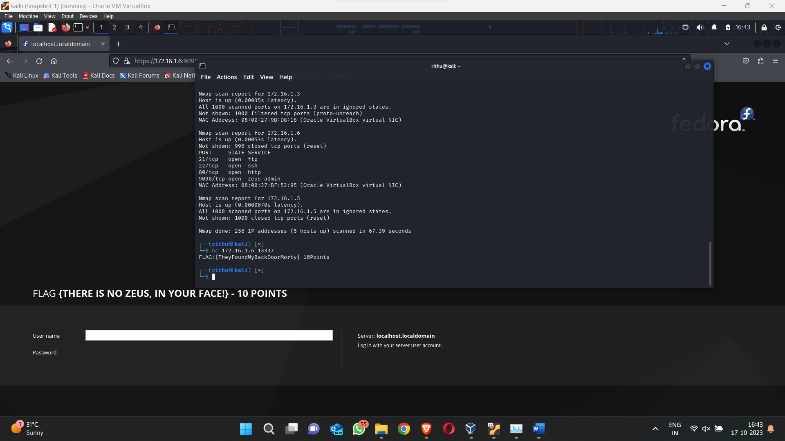

FLAG 3

Checking the list we have a file named FLAG.txt use command cat to open it

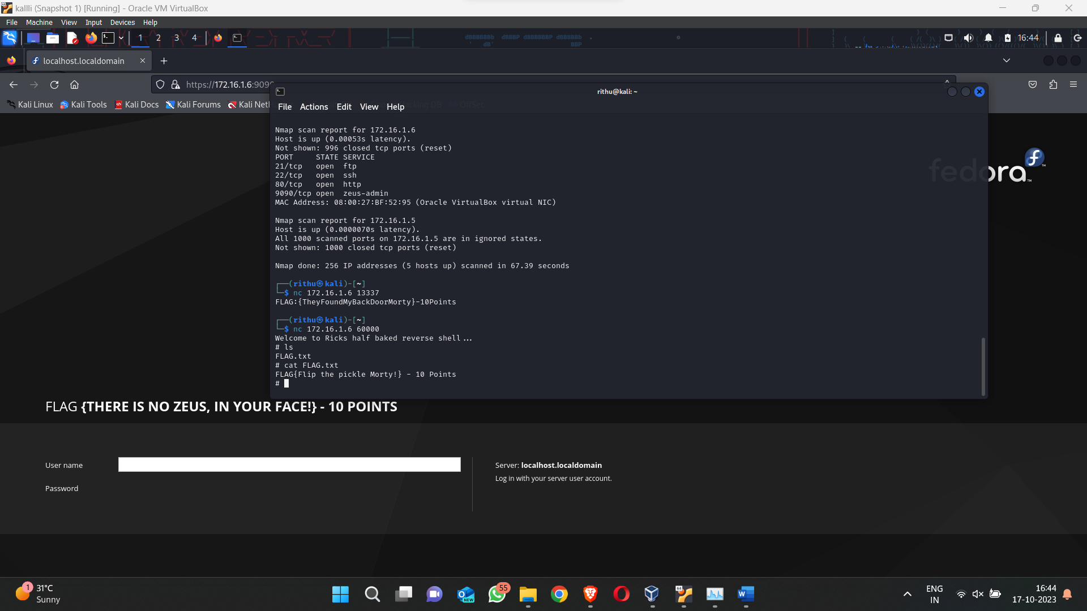

Let us search some of the directories and sub directories that this IP has

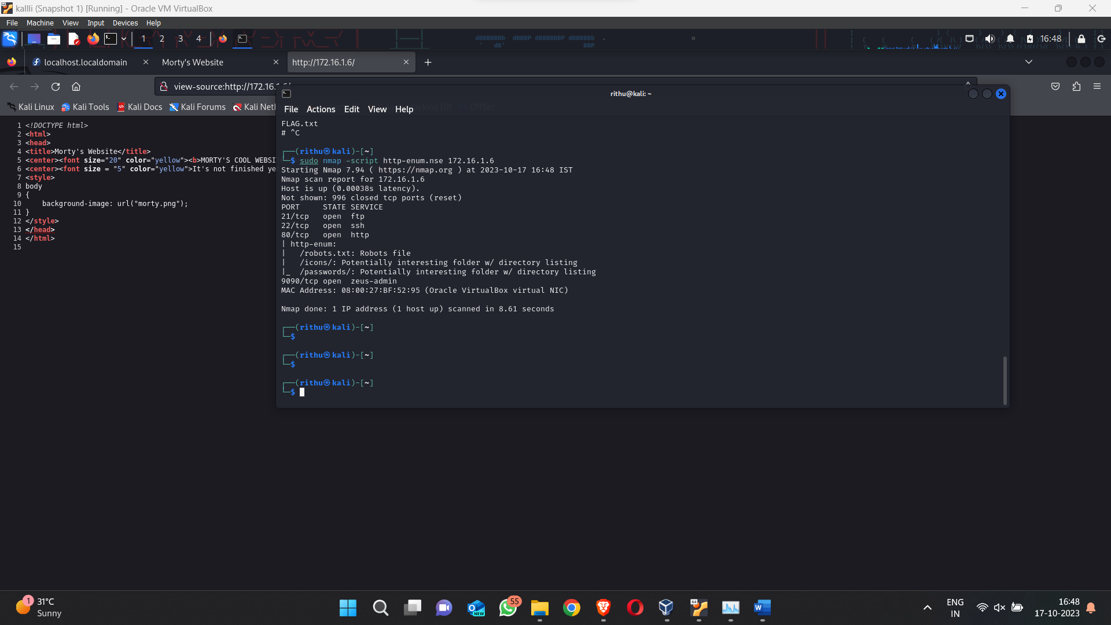

Opening the first subdirectory we have 3 links which didn’t actually lead anywhere but are fun to watch

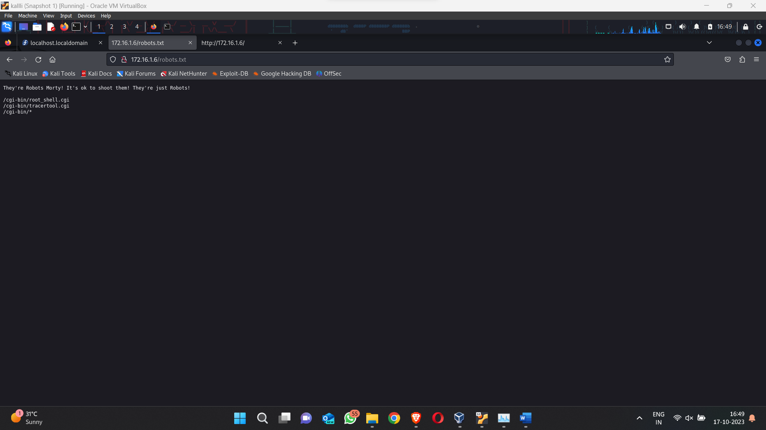

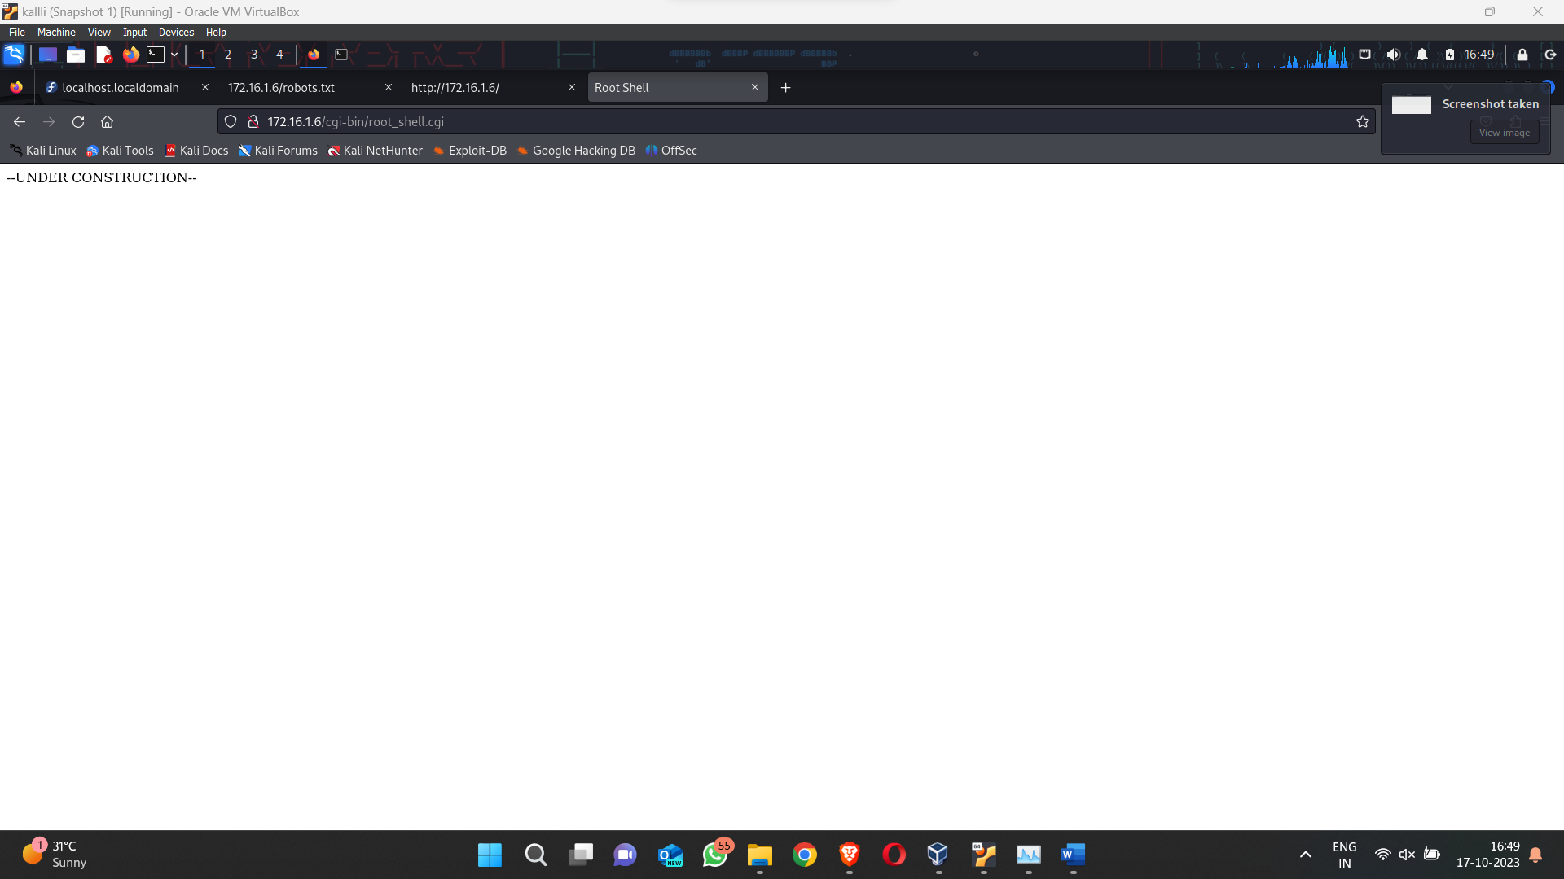

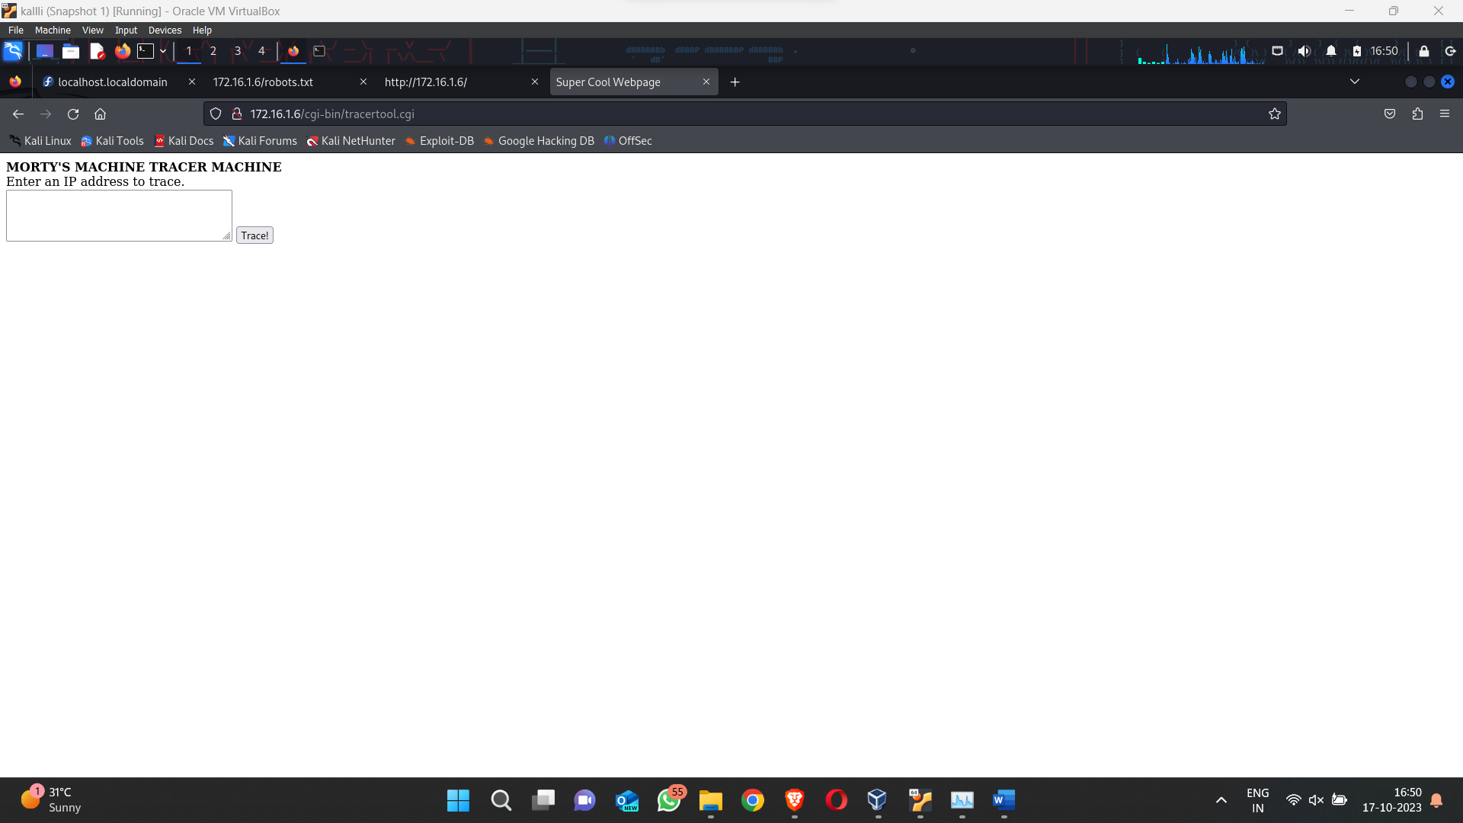

You can enter IP here to ping but it doesn’t do much

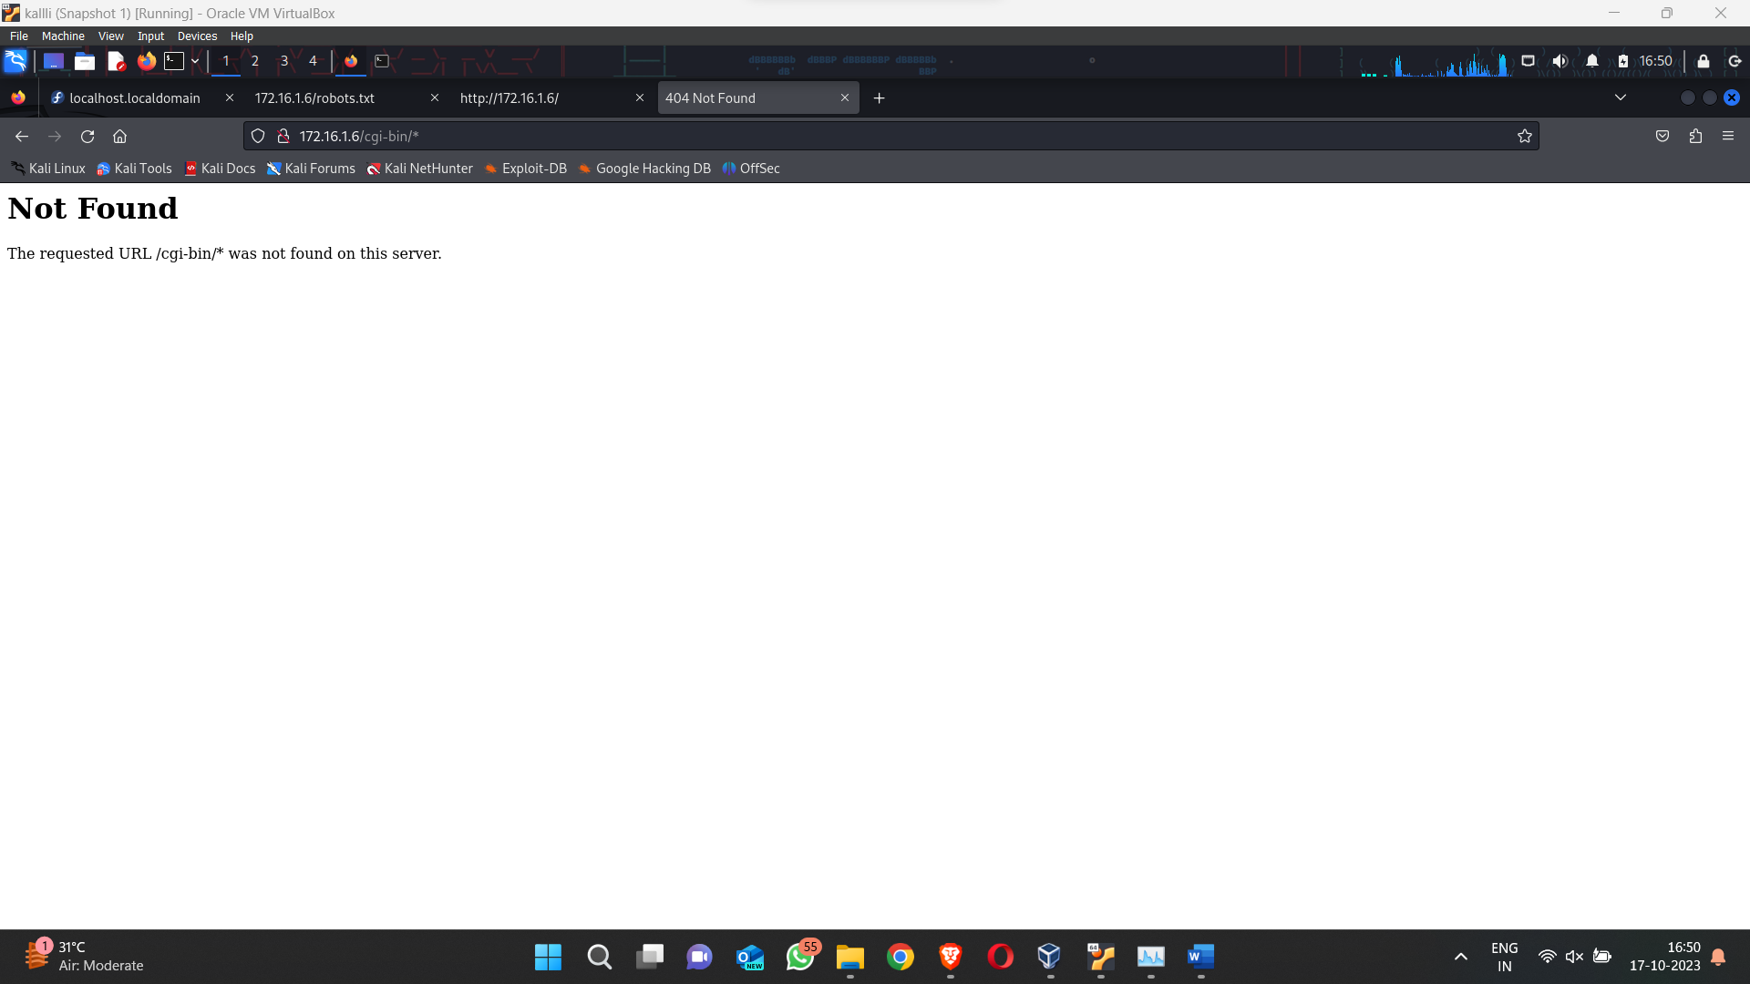

Next subdirectory we go to is icon which has some cool gifs but not really any flags

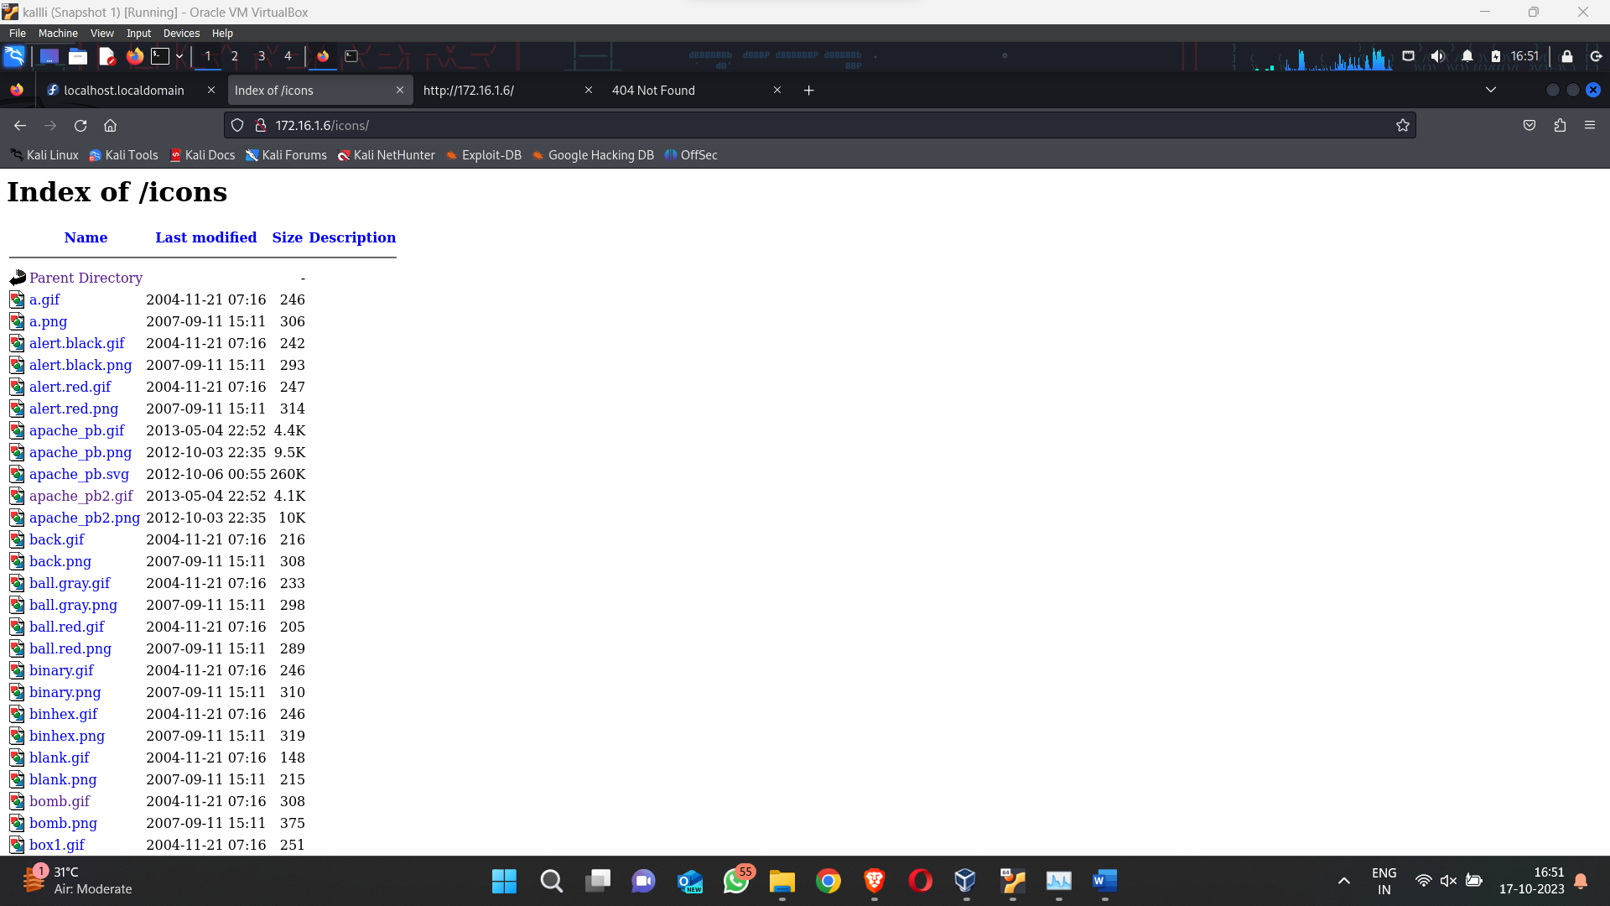

Next subdirectory we have is passwords now we are getting into interesting stuff

We have a file here called FLAG.txt open it to get our next flag

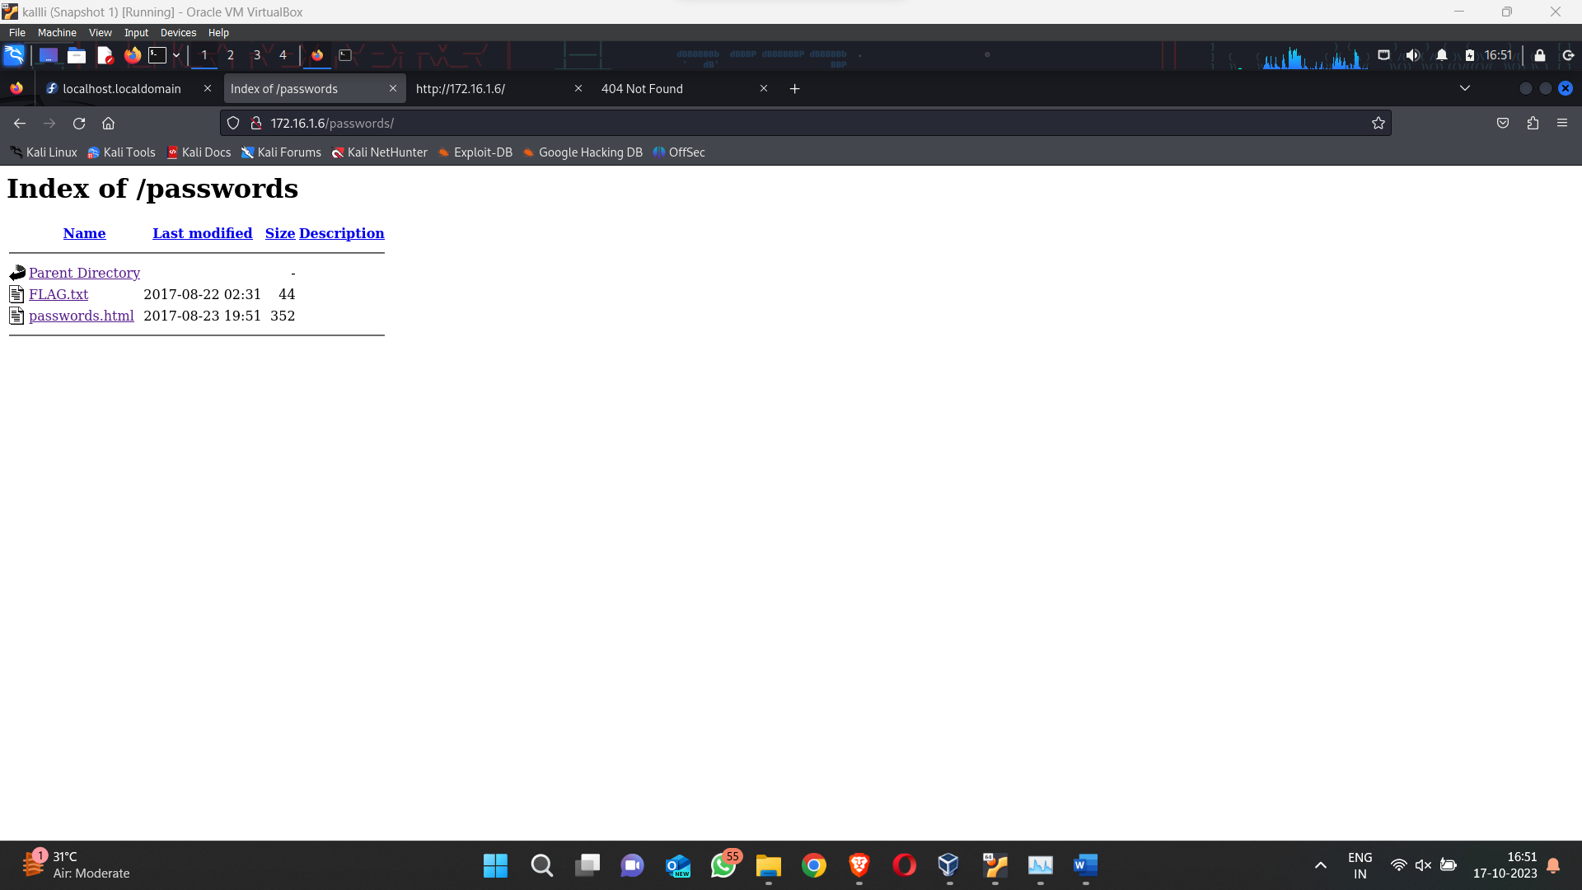

FLAG 4

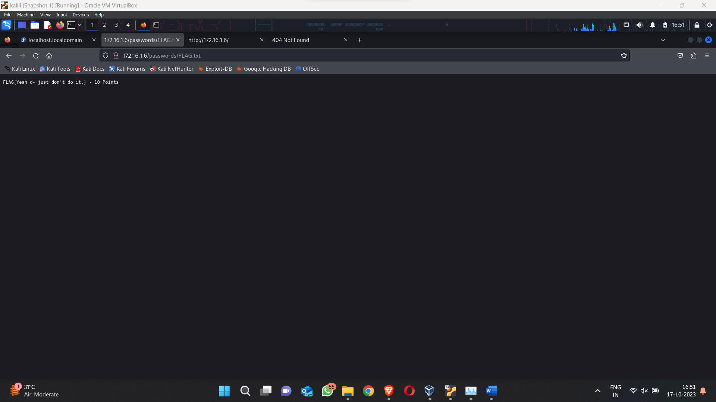

We have another file called passwords.html

On opening gives this message, hmm rick deleted the password??

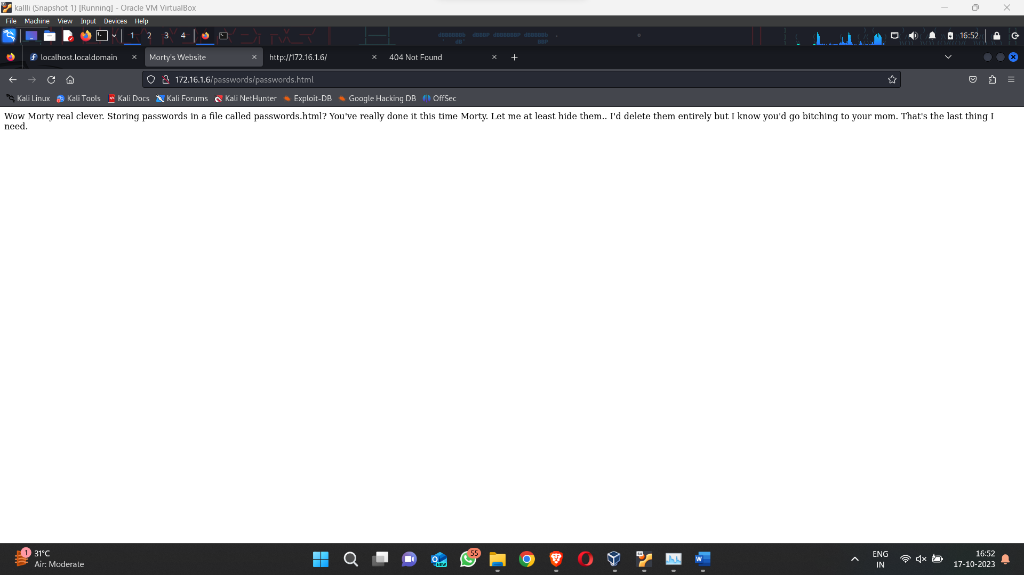

On viewing the source page of that message we get a password called winter :) cool

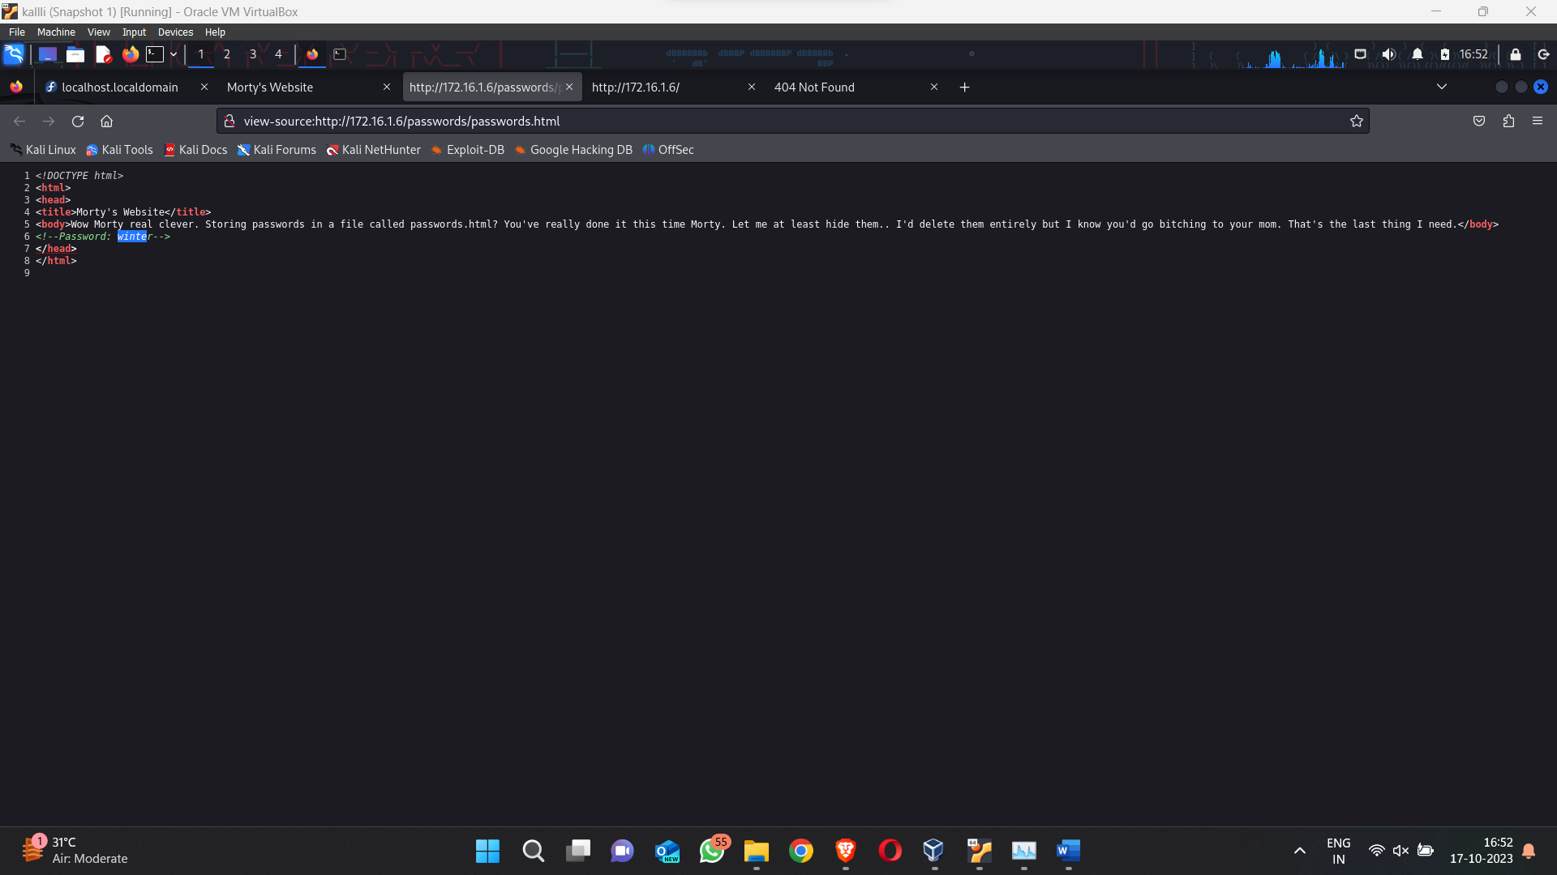

Now if you have ever seen Rick and Morty there’s a character called Summer

Now the password winter got me thinking maybe Summer could be the username

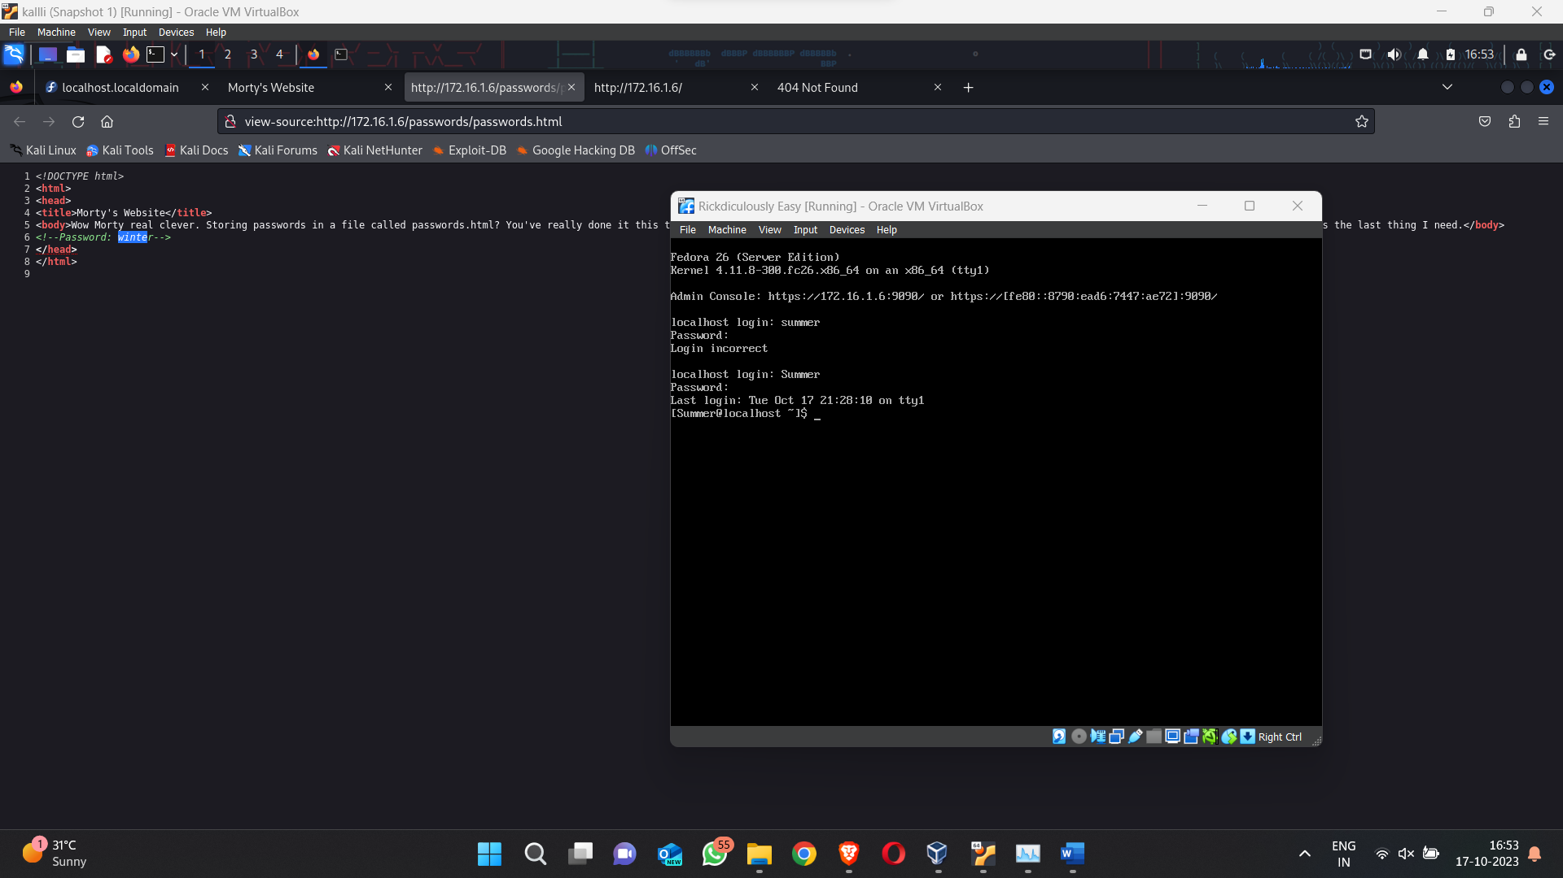

Failed the first time but got it on the 2nd try don’t lose hope

On checking the list, we have a file FLAG.txt

Go on use the cat command ….lol a cat appears. Use the head command to read FLAG.txt

FLAG 5

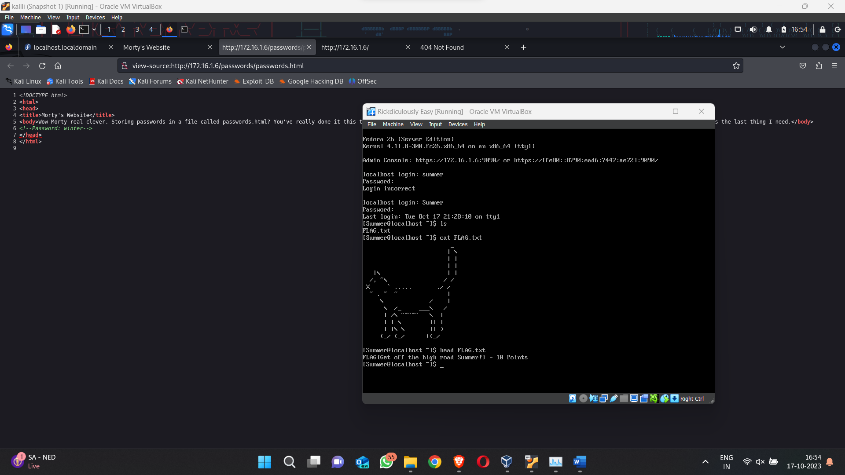

Now go back a directory using (cd ..)

You will see we have 3 folders

Let’s see the first one Morty

We have a zip file and jpg file but the zip file needs a password…

Try to read the jpg file using head

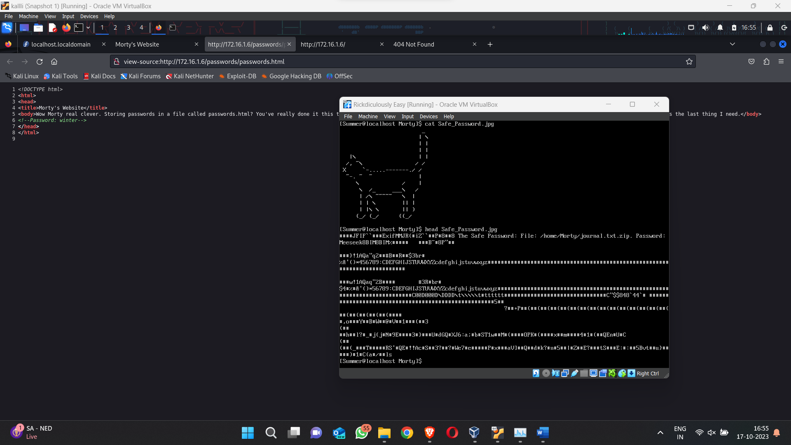

Oh we see a password called Meeseek

Let’s try this for the zip file

Open the zip file using unzip -c

We got it another password and one more flag

FLAG 6

